WOLMER’S TRUST HIGH SCHOOL FOR GIRLS’
THIRD FORM WORKSHEET
STANDARD FORM

SECTION A
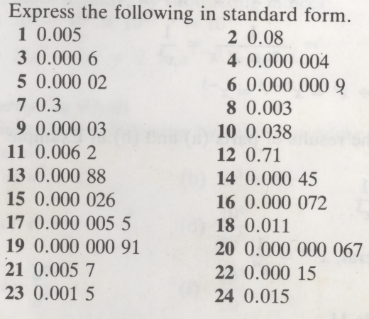

SECTION B
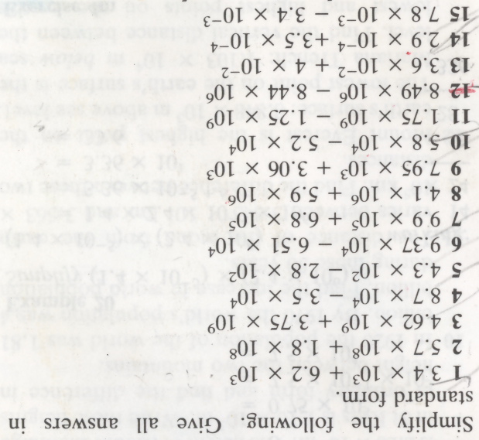
SECTION C
